STANDARD FORM
Pearson Edexcel - Thursday 6 June 2019 - Paper 2 (Calculator) Foundation Tier

Pearson Edexcel - Thursday 8 November 2018 - Paper 2 (Calculator) Foundation Tier

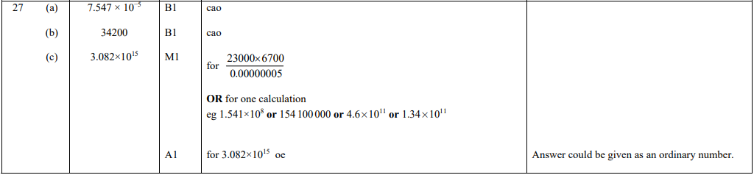

Pearson Edexcel - Tuesday 12 June 2018 - Paper 3 (Calculator) Foundation Tier

Pearson Edexcel - Thursday 2 November 2017 - Paper 1 (Non-Calculator) Foundation Tier

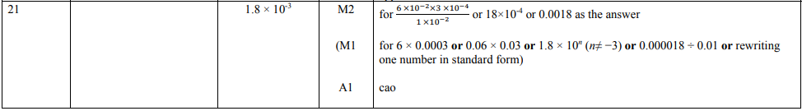

Pearson Edexcel - Wednesday 8 November 2017 - Paper 3 (Calculator) Foundation Tier

OCR Thursday 7 June 2018 – Morning (Non Calculator) Foundation Tier
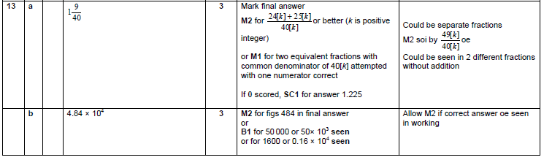

OCR Monday 6 November 2017– Morning (Calculator) Foundation Tier
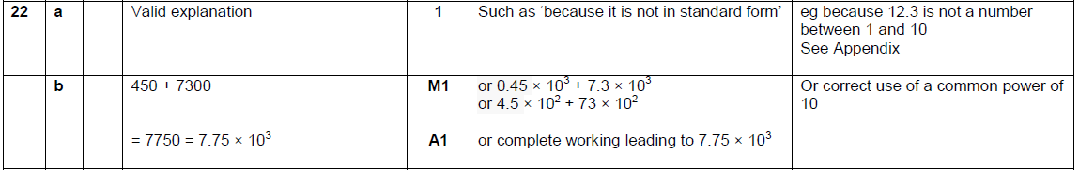

OCR Wednesday 8 November 2017– Morning (Calculator) Foundation Tier

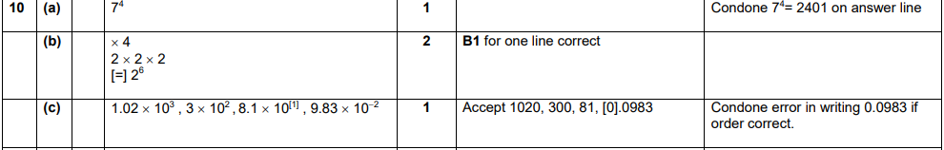

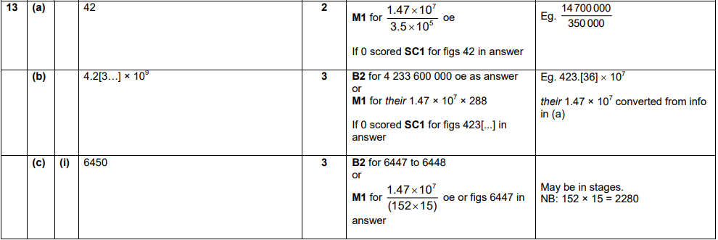
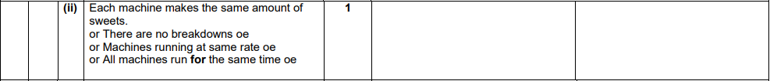
OCR Thursday 25 May 2017 – Morning (Calculator) Foundation Tier

OCR Sample Question Paper 2 – Morning/Afternoon (Non - Calculator) Foundation Tier

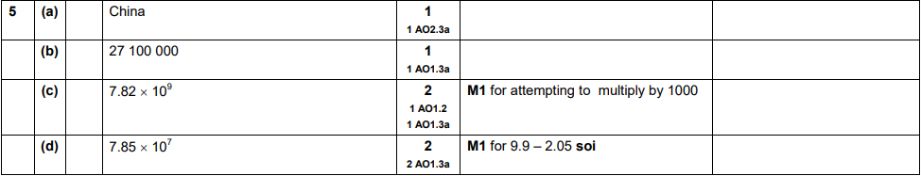

AQA Tuesday 19 May 2020 – Morning (Non-Calculator) Foundation Tier

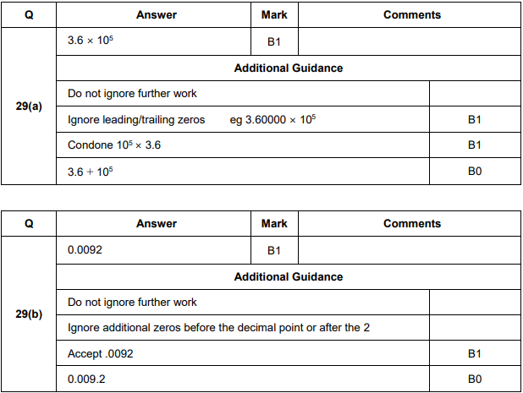
AQA Tuesday 21 May 2019 – Morning (Non-Calculator) Foundation Tier

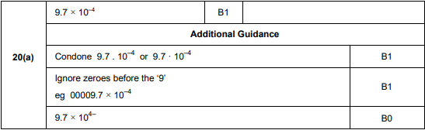
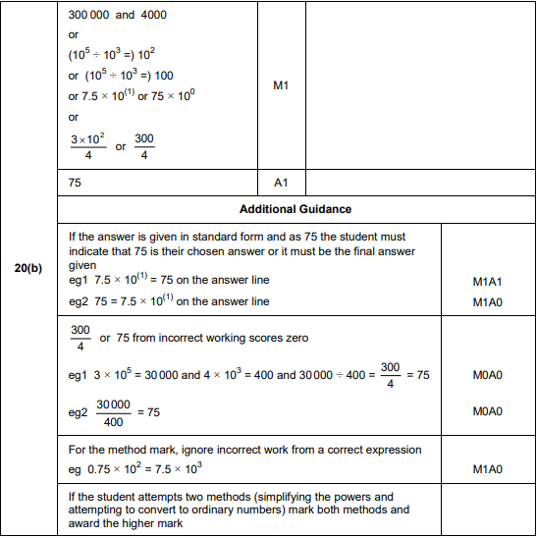

AQA Thursday 8 November 2018 – Morning (Calculator) Foundation Tier

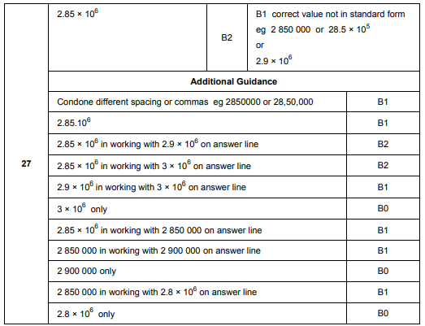
AQA Thursday 24 May 2018 – Morning (Non-Calculator) Foundation Tier

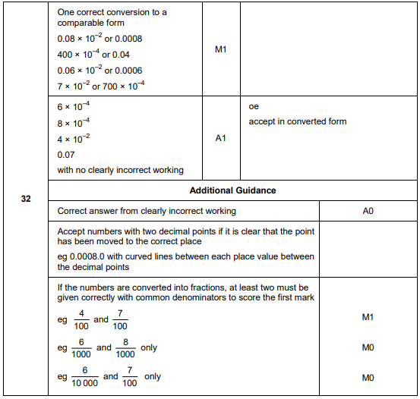
AQA Thursday 2 November 2017 – Morning (Non-Calculator) Foundation Tier

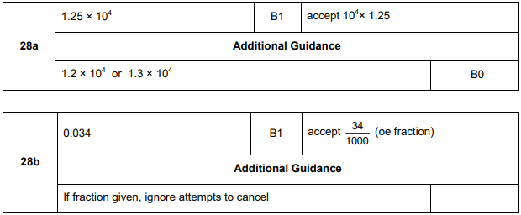
AQA Thursday 25 May 2017– Morning (Non-Calculator) Foundation Tier

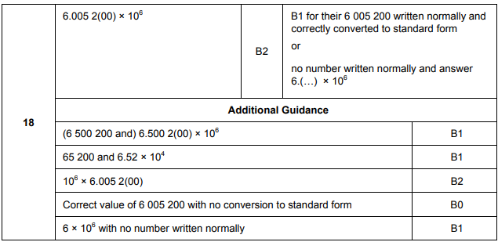
AQA Thursday 8 June 2017– Morning (Calculator) Foundation Tier

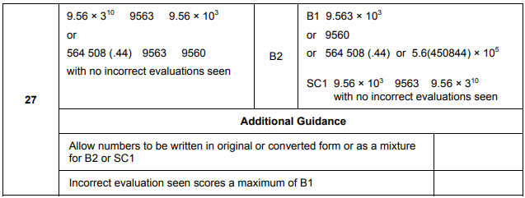

AQA Sample Paper 1– Morning (Non-Calculator) Foundation Tier

